SESSION 1: FALSE PLEASURES

Task 1: Spot the philosophical link between these pictures. Is one picture the odd one out? Why?
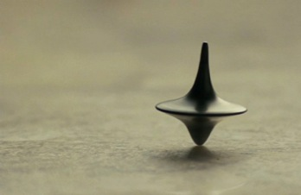
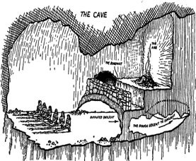

Key Sticky Question:
Is it dangerous to indulge in the false pleasures of reality television?

Answers from overleaf: All the images involve a situation where something is masquerading as reality: Truman from the Truman show lives a false life (but one that he thinks his real), Neo in the Matrix lives in an artificial world, in Inception we are uncertain as to what is a dream and what is reality, in Plato’s cave the prisoners think the shadows on the wall are the true reality, Made in Chelsea is presented as reality but the storylines are false, Putnam claims we could all be a ‘brain in a vat’ and be ignorant of it. There are many possibilities for the ‘odd one out’, and the point of this is just to make students think! One response is that Made in Chelsea is the ‘odd one out’ because those in the situation are aware of the manipulation of reality, and indeed, party to it.
Philosophical Fruit: Plato on False Pleasures
In the Philebus dialogue, Plato argues that there are three main types of false pleasure, which he is keen for us to avoid!
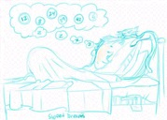
- Pleasure based on false hope

Plato gives the example of a man who gains much pleasure from imagining that he will become rich through discovering gold, when in fact, he never does. Compare this to those that dream of winning the lottery in modern society.

Socrates: There are then, assertions in each of us that we call hopes?
Protarchus: Yes
Socrates: But there are also those painted images. And someone often envisages himself in the possession of an enormous amount of gold and a lot of pleasures as a consequence. And in addition, he also sees, in this inner picture himself, that he is beside himself with delight.
Protarchus: What else!
Socrates: Now, do we want to say that in the case of good people these pictures are usually true, because they are dear to the gods, while quite the opposite usually holds in the case of wicked ones, or is this not what we ought to say?
Protarchus: That is what we ought to say.
Socrates: And wicked people nonetheless have pleasures painted in their minds, even though they are somehow false… So wicked people as a rule enjoy false pleasures, but the good among mankind true ones?
Protarchus: Quite necessarily so.
(Plato, Philebus 40a)

- Pleasure based on miscalculation
Plato gives the example of sick patients returning to health: Plato argues that the patients may believe that they gain pleasure, but are only really returning to the immediate state between pleasure and pain.

- Pleasure based on a false reality
A famous example of this is given in Plato’s Republic with his Cave Allegory: here, Plato compares ordinary people to prisoners tied in a cave, spending their whole life looking at shadows, thinking that they are the only true reality. He believed that we are similarly ignorant because we think that we have knowledge of complete reality, but in fact only the philosophers who have an understanding of the higher ‘world of the forms’ have a real comprehension of the world.

It is important to note that Plato does not deny that we gain pleasure from each of these assortments of pleasure, but he designates the pleasure to be ‘false’ due to the false nature of the object from which pleasure is gained.

Task 2: Consider the three types of false pleasure, and think of different examples for each type of pleasure. Discuss suggestions.

Type of False Pleasure | Plato’s Example | Other Examples
Pleasure based on false hope | Plato gives the example of a man who gains much pleasure from imagining that he will become rich through discovering gold, when in fact, he never does. | The pleasure gained dreaming of scoring a goal in football for England when you have no real chance of representing your country.
Pleasure based on miscalculation | Plato gives the example of sick patients returning to health: Plato argues that the patients may believe that they gain pleasure, but are only really returning to the immediate state between pleasure and pain. | The pleasure gained from spending time with your first boyfriend. You may simply have nothing to compare the pleasure to.
Pleasure based on a false reality | A famous example of this is given in Plato’s Republic with his Cave Allegory: here, Plato compares ordinary people to prisoners tied in a cave, spending their whole life looking at shadows, thinking that they are the only true reality. He believed that we are similarly ignorant because we think that we have knowledge of complete reality, but in fact only the philosophers who have an understanding of the higher ‘world of the forms’ have a real comprehension of the world. | The pleasure gained by thinking that you are extremely popular when in fact you are widely disliked.

Task 3: Run through a series of images (or clips) of current/old reality televisions shows. What is the extent of reality shown in each ‘reality’ television show? To consider: Are these are the third type of false pleasure that Plato speaks of, or not? Or are these examples of a different (worse?) type?

Some suggested programs for discussion: The Apprentice, Made in Chelsea, The Only Way is Essex, Big Brother, I’m a Celebrity Get me out of here, X Factor, Keeping up with the Kardashions, etc.

Philosophical Fruit: Plato was against indulgence in false pleasures for many reasons:

- He firstly thought that seeking truth was a priority, and focusing on something that lacks a basis in truth distracted us from this focus. It was for this reason that he spoke so strongly against enjoyment of art in The Republic because he saw it as a poor imitation of the physical world, which was therefore several steps away from focusing on the true world of the forms. “Then imitation is far removed from the truth, for it touches only a small part of each thing and a part that it itself is only an image” (Republic 268).

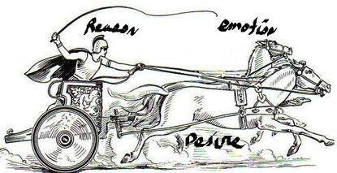
- Plato argued that such pleasures would in their lack of focus on truth drive us away from allowing the rational part of the soul to be in control, instead making us base decisions on physical instincts and desires. He argued this would lead to an imbalanced soul, ruled by the appetitive and spirited parts of the soul. Plato had a tripartite view of the soul composed of rational, appetitive, and spirited elements. He argued that in the balanced soul of the Philosopher, the rational element would be in control and allow the other two parts to be moderated, using the analogy of a charioteer steering two horses.

- Lastly, Plato believed that the pleasure gained from such activities would reinforce the view that such activities were something you should indulge in, and it was thus this element of enjoyment that makes such activities even more dangerous!

In summary, Plato considered false pleasures to be powerful, and therefore dangerous. He argued that poetry, drama, music, painting, dance, are unethical as they all stir up our emotions and can strongly influence our behavior in an irrational manner which leads us away from pursuit of the truth.

“Then the imitative poet who aims at being popular is not by nature made, nor is his art intended, to please or to affect the rational principle in the soul; but he will prefer the passionate and fitful temper, which is easily limited...And therefore we shall be right in refusing to admit him into a well-ordered state, because he awakens and nourishes and strengthen the feelings and impairs the reason … Poetry feeds and waters the passion instead of drying them up; she lets them rule, although they ought to be controlled, if mankind are ever to increase in happiness and virtue.’

For that reason Plato insisted that music along with poetry and drama and the other arts, should be strictly censored. Only when young people were ready should they be exposed to falsehoods and depictions of evil to test the strength of their character.
Instead, he thought we should indulge in pure or true pleasures such as those of philosophical and abstract thought, and in particular the study of mathematics (and his World of the Forms). He argued that physical pleasures should be limited to our basic needs.

FINAL TASK: Consider Plato’s case for banning ‘false pleasures’ from his ideal state, and from the life of the ‘moral’ individual. Separate students in teams. Each team has to produce a one-minute response to the questions:

Discuss: Is indulging in false pleasures dangerous? If so, which might be the most dangerous type of false pleasure? Should reality TV be avoided due to the manipulation of the truth involved?

Teachers and pupil leaders: circulate encouraging students to produce clearly structured arguments, use original real life examples to support the points that they make. Where appropriate, play devil’s advocate to their arguments.

The Fruits of Labour:
Each group choses a ‘speaker’ to deliver their speech to the society. Student leaders to introduce and manage session. Each group is given one minute to speak, following by one minute of questioning by other groups. At the end the society takes a vote on which team they think offered the strongest argument.

