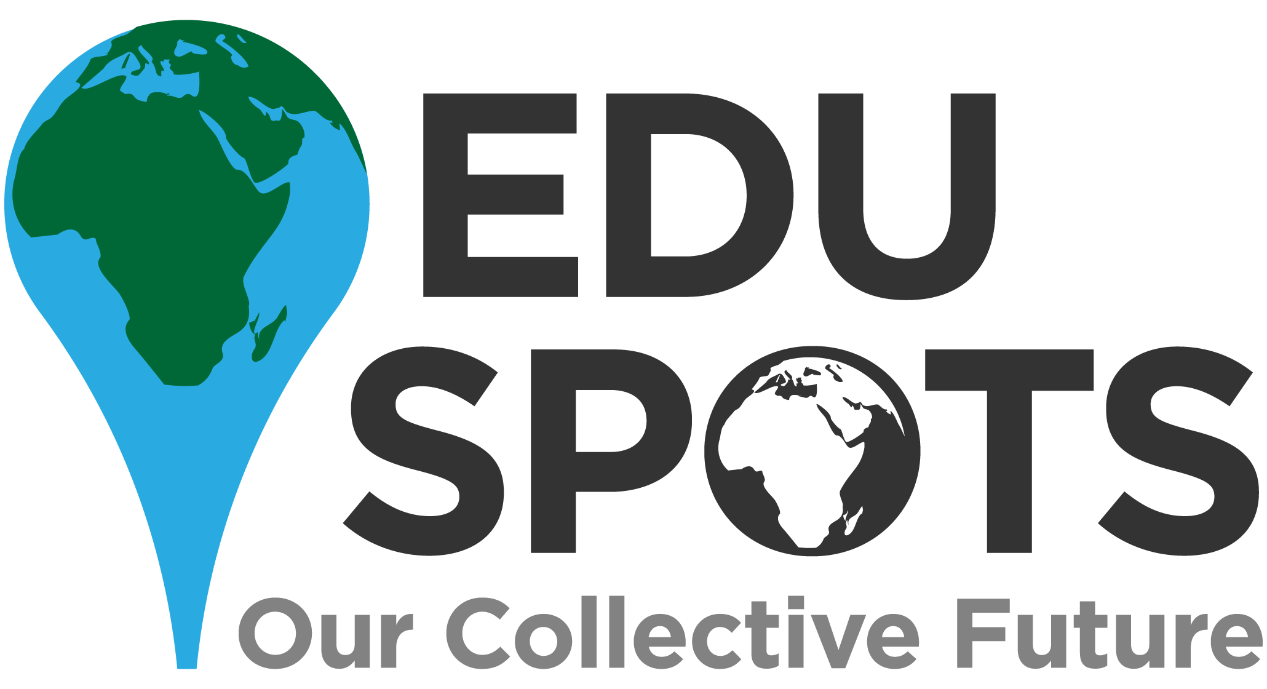
EduSpots UK – Graphic Design Support Officer

Location: Home-based
Reporting to: The Chair of Trustees
Remuneration: Voluntary position
Time Commitment: Flexible
About Us
EduSpots is a small but rapidly growing education charity dedicated to supporting individuals in Ghana, and the UK, to be changemakers in the world. EduSpots primarily exists to enable community members – whether teachers, parents or students – to realise their ambitions for their community through education. We connect individuals and communities who are passionate about education, and driven to make a difference, in order to achieve our vision of ‘A world in which communities unite to create the future they want to see.’
Until 2019 we were known as ‘Reading Spots’, set up in 2016 to help communities in Ghana build and run local libraries and reading centres known as ‘Spots’. In 2018 we won the Times Educational Supplement’s (TES) ‘International Award’ for the best UK international education project.
By 2019, with a network of thriving ‘Spots’ across Ghana, it was becoming clear that these spaces were developing into wider education places and not just ‘reading’ spots. This combined with the development of our ‘Catalyst’ programmes and the birth of our online courses, it felt the right time for a change of name to EduSpots.
We are excited by our future.
In 2021 Edu Spots will be:
- Continuing to oversee and support the existing network of community-led ‘Spots’
- Rolling out a new and innovative ‘Catalyst’ training programme, giving our volunteers the skills, knowledge and experience they need to lead and influence positive, sustainable change in their communities through their ‘Spots’.
- Managing the amazing growth of our global online courses & Schools Partnership work, enabling more people around the world to effect positive change
About this role
As we move into an exciting new phase of development, the role of Graphic Design Support – UK, will be key to supporting the work of the Charity and developing consistency of design across the organisation. We are not being specific about the skills we are looking for, we would love to hear from people with a wide range of experience in this field.

Are you a professional who would like to offer your skills? Or you may be just starting out and looking for experience in a real-life setting. Or you could just be someone who has a personal interest in this kind of work but not necessarily have had formal training. We would love to hear from you!

We need someone who can help us with some, or all of these, areas:

- Developing our branding across the organisation
- Identifying opportunities where we can strengthen our messaging with funders, stakeholders etc.
- Producing strong and engaging promotional materials and course content materials for our online courses and school partnerships work
- Producing web content/design support
- Producing newsletters, posters, annual reports etc.
- Illustration/ video / animation skills would be a bonus

This is a flexible role which can be shaped around the interests and skills of the volunteer. So, if it sounds interesting but you’re not sure if you would be able to do all the elements, please do get in touch, we would love to hear from you. If you would like to discuss the role in more detail please do contact us at info@eduspots.org and will be in touch.
Or to apply please send your CV with a covering letter to Cat Davison, Chair, at info@eduspots.org
EduSpots is committed to the safeguarding of children & vulnerable adults. Appointment will be subject to child protection screening appropriate to the post.
Follow us on Twitter @eduspots or find us on Facebook and Instagram

